|  |  |  |  |  |  |
| --- | --- | --- | --- | --- | --- |
| Date | 30-Nov-22 | | | Tester Name | Mayuri Patel |
| Environment | Penfax - Test | | | Login used |  |
| Operating System | Select OS | Version: | Update: | | |
| Software Used | Select Software | Version: | Update: | | |
| Select Software | Version: | Update: | | |
| Release version | 22.4.1 | | | | |
| Title |  | | | | |
| Test Type | Regression | | | | |
| Test Scenario | Change payments from monthly to annual | | | | |
|  |  | | | | |
| Expected Results |  | | | | |
| Pass/Fail | Pass | | | JIRA# | N/A |

Describe your steps with screenshots:

Find a member to change the payments from monthly to Annual

Open that member Profile

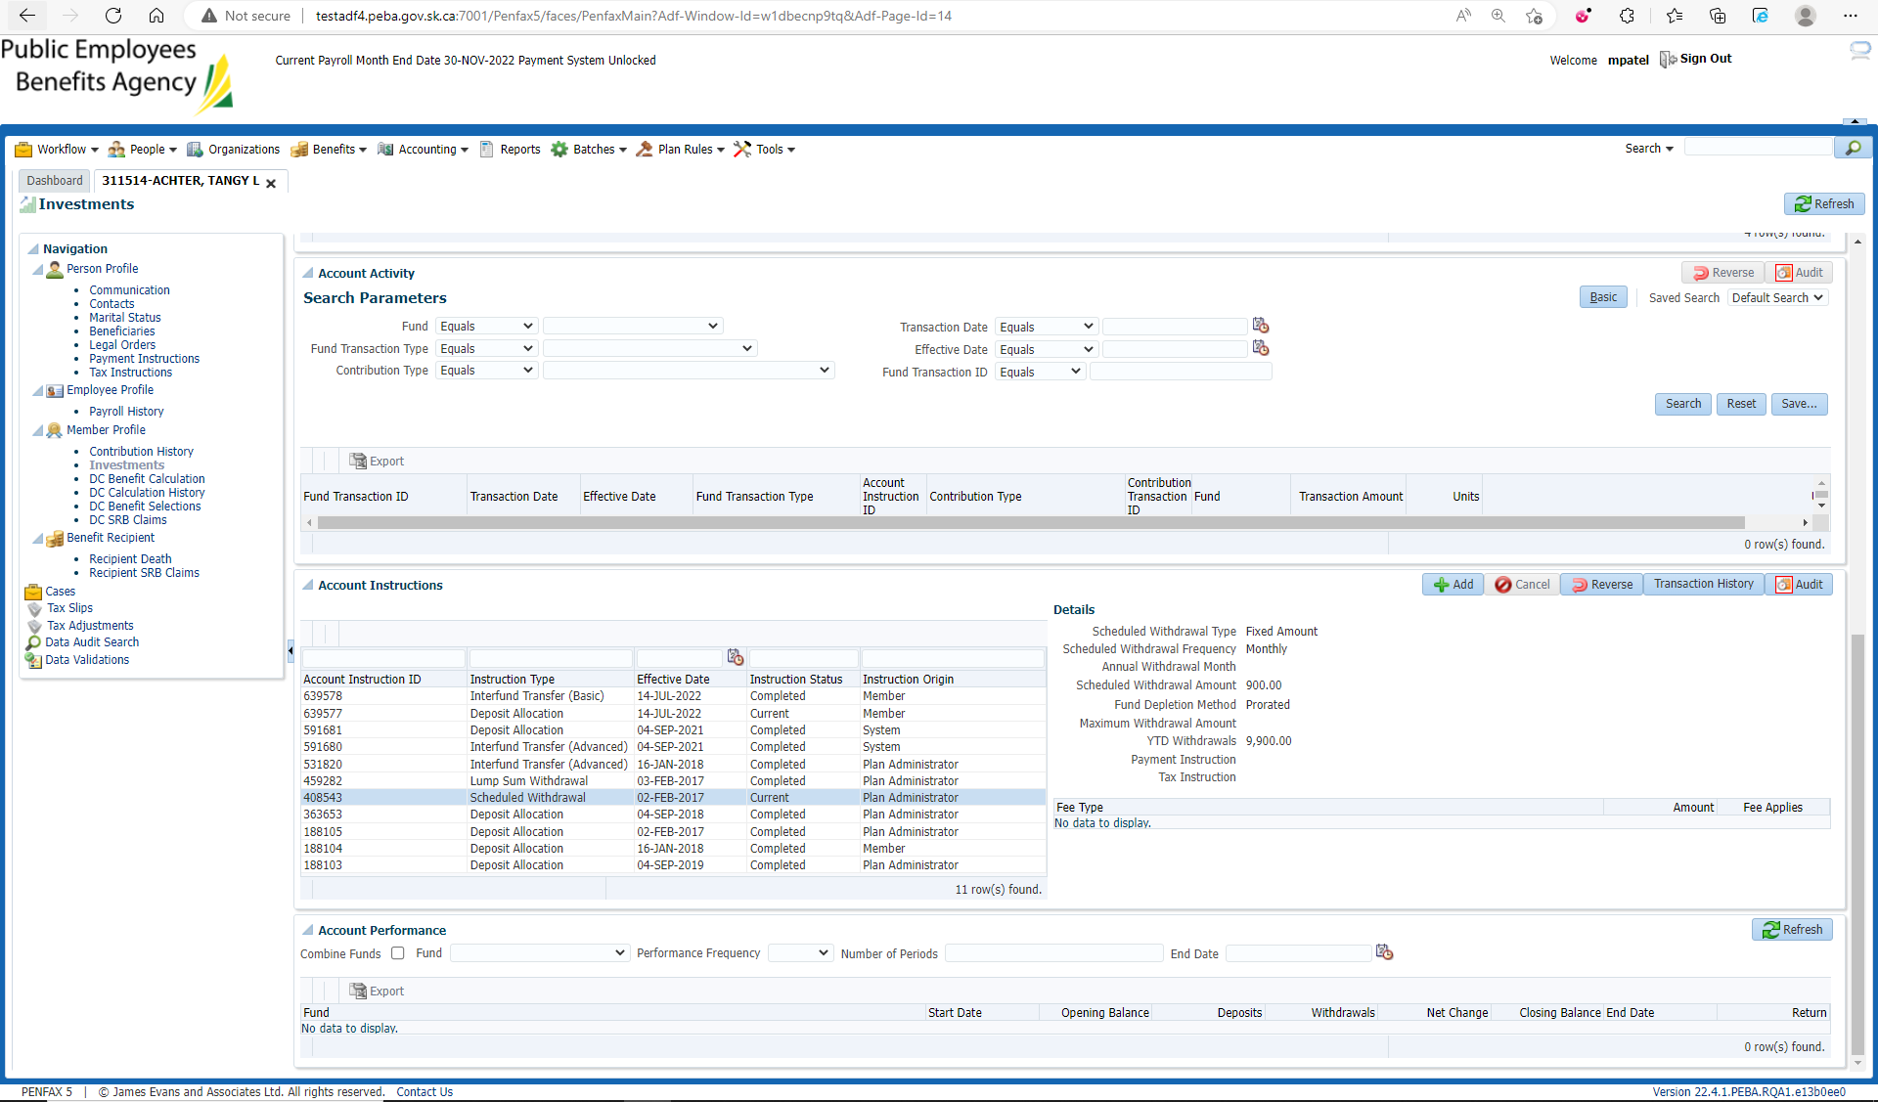

Go to Investments🡪 Account Instruction

Add Account instruction

Set Schedule withdrawal Frequency to Annual and fill other mandatory details and Save

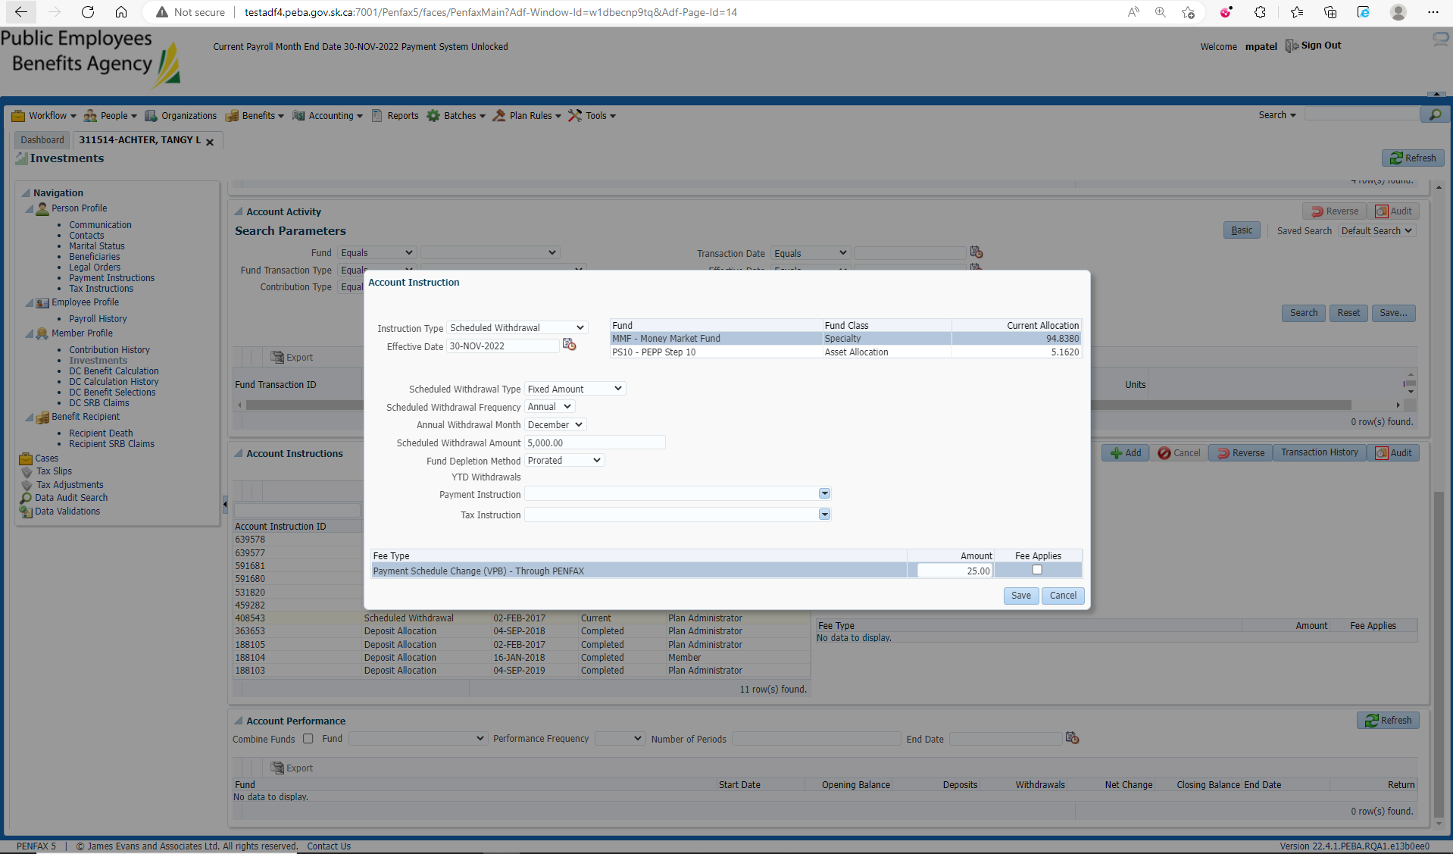

Old Account Instruction is completed and newly added instruction becomes the current one

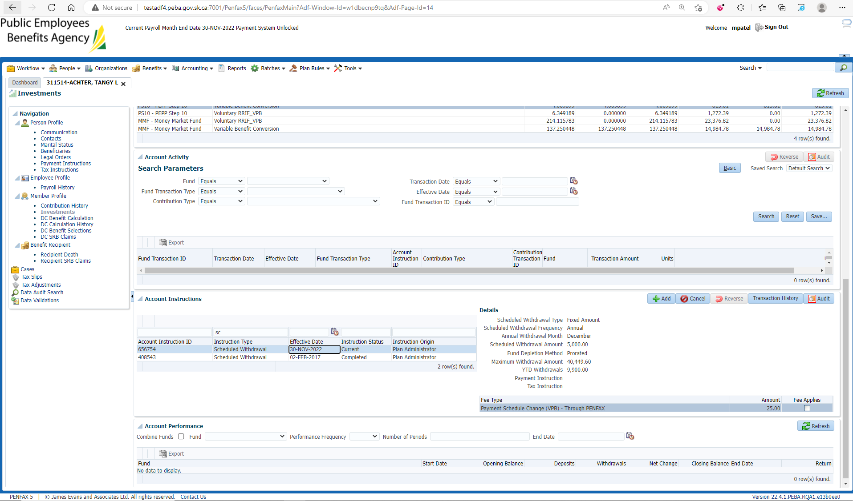

After Overnight PIT Batch make sure for information change outbound document under communication

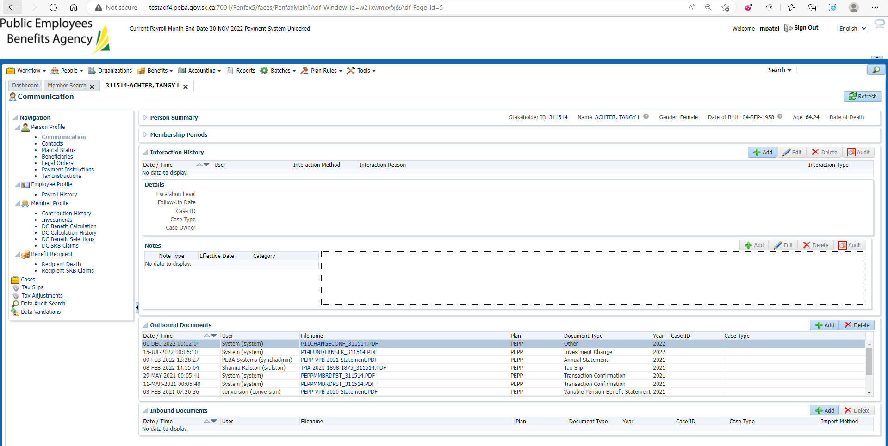

Same Steps processed through Penweb

